Welcome to Holderness Health. Please help us by filling in this questionnaire as it may take some time for your previous medical records to reach us. The information you provide is essential to help us with your future treatment.

We would ask that you use the enclosed practice leaflet to familiarise yourself with details of the Practice.

If you have any queries, please do not hesitate to contact our Patient Services Team at any of our reception desks or by calling the practice on 0333 332 4242. All the information on this form will be treated as strictly confidential. Thank you for your assistance.
PERSONAL DETAILS

Full Name: |  |  | Date of Birth:
Address:
 |  |  | Postcode:
Home Telephone Number:
Work Telephone Number:
Mobile Telephone Number:
Email Address:

NAME AND ADDRESS OF PREVIOUS DOCTORS SURGERY

Postcode:

Patient Consent for Text Messaging:

If you are happy for us to do so, we can share information with you by text. This includes appointment reminders, invitations to book appointments for services such as the annual flu vaccination, direct communications about your treatment/care, and important practice updates e.g. changes to services.

Please read the statements below and sign to indicate your consent to receiving text messages from us.

- I consent to the Practice contacting me by text message

- I acknowledge that appointment reminders by text are an additional service and these may not take place on all/or on any occasion, and that the responsibility for appointments or cancelling them still rests with me.

- I can cancel the text message facility at any time

- The Practice may not offer a reply facility to enable patients to respond to the sent text message directly

- I agree to inform the Practice if my mobile number changes or if it is no longer in my possession.

Patient Signature: |  | Date:

HEIGHT / WEIGHT

What is your height? |  |  |  |  |  | What is your weight?
EXERCISE

How would you describe your activity level? |  |  |  |  |  |  | None / Light / Moderate / Heavy
Would you like further advice about services available to help with exercise? |  |  |  |  |  |  |  |  |  | Yes / No
SMOKING STATUS

 | Never Smoked |  |  | Current Smoker | If so, how many per day?
Do you use or have you used a vape or e-cigarette? |  |  |  |  |  |  |  |  |  | Yes / No
Would you like further advice about services available to help you to stop smoking? |  |  |  |  |  |  |  |  |  | Yes / No

ALCOHOL CONSUMPTION

How many units of alcohol do you drink per week?
Would you like further advice about services available to help you with your alcohol consumption? |  | Yes / No

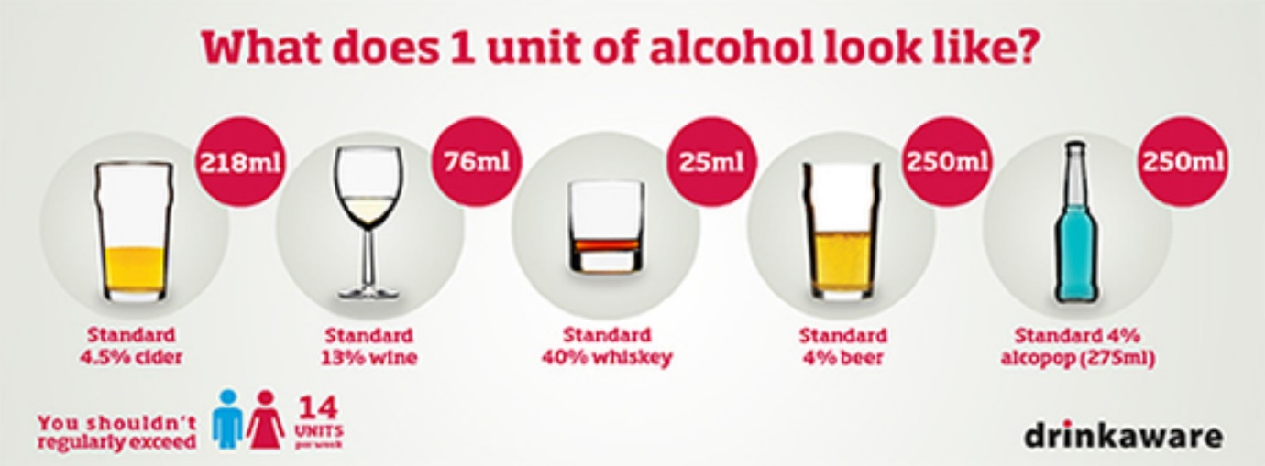

MEMORY

Do you have any concerns that your memory may not be as good as it used to be and causing you problem? | Yes / No
If YES would you like to see one of our trained staff? | Yes / No

DISABILITIES

Do you have any disabilities:
Hearing Impaired
Registered Blind or Partially Sighted
Speech Problems
Wheelchair User
Other Disability (please provide details)

FAMILY HISTORY

Have any of your immediate family (i.e. father, mother, sister, brother) suffered from:
 | Asthma |  | Heart Attack / Angina
 | Breast Cancer |  | High Blood Pressure
 | Bowel Cancer |  | High Cholesterol
 | Diabetes |  | Strokes

VETERANS

Are you an armed forces veteran? | Yes / No
If YES would you wish to access the armed forces veteran services? | Yes / No

MEDICATIONS

If you take any medications please supply a copy of your last prescription or bring in your labelled medication box(es).

If you take any medicines, please bring the list from your previous surgery to the dispensary.
If this is not available, please fill in the table below. An example is filled in for you.

Drug Name | Drug Strength | How Many and How Often
Example | 250mg | One, twice a day

CARERS

Do you care for anyone else? | Yes / No
If YES would you like to be coded as a Carer on your medical record? | Yes / No
Do you have anyone who looks after you or your daily needs as a Carer? | Yes / No
If you have answered YES to any of the above, and you would like to complete a carer form you can obtain one from the Patient Services Team.
Internal Use: If a completed Carer form has been returned, a task should be sent to the Proactive Care team.

NEXT OF KIN

Please provide next of kin details:
Full Name:
Relationship:
Address:
Postcode:
Home Telephone Number:
Mobile Telephone Number:

PATIENT PARTICIPATION GROUP

Holderness Health has set up a Patient Participant Group (PPG) as we would like to know how we can improve our service to you and how you perceive the Practice and our staff. Our PPG meets regularly to discuss a wide range of issues.
I would like to be involved in the Holderness Health Participation Group |  | Yes / No

ETHNICITY What is your ethnic group? (please tick)

WHITE |  | BLACK OR BLACK BRITISH
 | British |  | Caribbean
 | Irish |  | African
 | Any other White background |  | Any other Black background
ASIAN OR ASIAN BRITISH |  | MIXED
 | Indian |  | White and Black Caribbean
 | Pakistani |  | White and Black African
 | Bangladeshi |  | White and Asian
 | Any other Asian background |  | Any other Mixed background
CHINESE OR OTHER ETHNIC GROUP |  | DO NOT WISH TO STATE
 | Chinese |  | Not stated
 | Any other Mixed background
The ethnic origin categories are those used in the 2001 Census (Office of Population Censuses and Surveys) and are recommended by the Commission for Racial Equality and the Bar Council
Do you speak / understand English? |  |  |  | Yes / No
Do you require an interpreter? |  |  |  | Yes / No

